Grammar
1 Complete the dialogue with the correct form of the verbs given.
A: Robert! What (1) ……………………… (you/do) here? You’ve got a test at 10.30!
B: We (2) ……………………… (just/finish) it. Is that your physics homework?
A: Yes. I (3) ……………………… (not do) it last night. I’ve decided I (4) ……………………… (give) a presentation about wind power.
B: If you (5) ……………………… (look) on the Internet, you’ll find something interesting.
A: OK. Do you want to come swimming later?
B: I (6) ……………………… (can). I always (7) ……………………… (have) a basketball match on Wednesdays.
A: Do you think you (8) ……………………… (win) today?
B: Their best player (9) ……………………… (can’t) play last time, but he (10) ……………………… (play) today, so we’ll see!
/ 10

2 Choose the correct alternatives to complete the sentences.
1 Would you like some/a/many rice with your meat?
2 Shall we meet under/in front of/above the cinema?
3 The road is icy. You must ride your bikes quickly/carefully/easily.
4 I wanted to make a cake this morning, but there weren’t/wasn’t/isn’t any eggs.
5 Shakespeare is the best/more/most famous writer in
my country.
/ 5

3 Correct the mistakes in the sentences. One sentence is correct.
1 Were you think the history lesson was difficult?
………..……..………..……..………..……..………..……..………..……..………..
2 I’m hardly ever home on Saturday afternoons.
………..……..………..……..………..……..………..……..………..……..………..
3 You don’t have to leave your bikes in the classroom. Someone might fall over them.
………..……..………..……..………..……..………..……..………..……..………..
4 If it didn’t rain soon, the flowers will die.
………..……..………..……..………..……..………..……..………..……..………..
5 The Eiffel Tower was build in 1889.
………..……..………..……..………..……..………..……..………..……..………..
/ 5

4 Choose the best answers (A, B or C) to complete the email.

Hi Sarah,

How’s it going? Have you finished writing the first part of our presentation (1) ……………………… ? I found some interesting details about Volta’s early life. He didn’t go to university and he wrote his first book when he was only 24. If you want more information, I (2) ……………………… it to you later.

Yesterday, I (3) ……………………… on the details of the experiment that he did when he invented the battery. I found some great pictures. I think we (4) ……………………… try to write a little play about it. We could act it out together. What do you think? We want our presentation to be the (5) ……………………… . That could make it different.

Call me later.

Claire

1 A yet B already C just
2 A send B will send C am sending
3 A am working B have worked C was working
4 A should B don’t have to C must
5 A better B more interesting C best
/ 5

Total | / 25
Vocabulary
5 Choose the correct alternatives to complete the sentences.
1 There was a terrible storm/cloud last night with lots of wind and rain.
2 I don’t have much jewellery/belts. I want to buy a ring.
3 We can’t stop pollution/poverty. There will always be rich and poor people.
4 Now her exams have finished Petra looks more relaxed/stressed.
5 There are some dangerous sharks/bears in this forest.
/ 5

6 Complete the sentences with the correct answer, A, B or C.
1 Sophie is very ……………………… and she always gets good marks.
A cheerful
B kind
C intelligent
2 I forgot to take the rubbish ……………………… last night!
A out
B off
C for
3 You mustn’t ……………………… the ball with your hand.
A dived
B hit
C ran
4 I’m taking my books back to the ……………………… and I’ll get some more.
A library
B bookshop
C museum
5 What time do you get ……………………… on Sunday morning?
A out
B up
C on
/ 5

7 Complete the sentences with one verb in each gap.
1 We ……………………… our bikes all the way to the river.
2 We ……………………… sightseeing every day in Paris.
3 Can you ……………………… the table for five people?
4 I ……………………… washing the dishes when you phoned.
5 My sister often ……………………… online with her friends.
6 The models for the charity fashion show must ……………………… dressed at 2.30 pm.
7 Joe ……………………… the ball so high it nearly left
the stadium!
8 I don’t really like skating. I always ……………………… over.
9 Penicillin was ……………………… by Alexander Fleming
in 1928.
10 It’s going to ……………………… tonight so we can go
skiing tomorrow.
/ 10

8 Choose the best answers (A, B or C) to complete the email.
Hi Carl,

We had a great time on holiday. We went to Vienna to see a(n) (1) ………………………! The music was wonderful. I really enjoyed it, but my brother Ben got a bit (2) ……………………… . He spent the time reading the (3) ……………………… to the city!

Then we went skiing. My mum was a bit worried. She broke her (4) ……………………… last time she went! But everything was fine. There was plenty of (5) ……………………… , too. I loved it!

Speak soon.
Ted
1 A opera  B film  C ballet  2 A disappointed  B surprised  C bored  3 A novel  B guidebook  C passport | 4 A ear  B ankle  C stomach  5 A fog  B rain  C snow

/ 5

Total | / 25
Use of English
9 Complete the second sentence so that it means the same as the first. Use between two and five words.
1 The water bottle is nearly empty.
There ……………………… in the bottle.
2 It’s not a good idea to eat a lot of sugar.
You ……………………… a lot of sugar.
3 Anna’s dad isn’t a very careful driver.
Anna’s dad ……………………… .
4 J K Rowling wrote the Harry Potter books.
The Harry Potter books ……………………… J K Rowling.
5 Alexander Graham Bell invented the telephone.
The ……………………… the telephone was Alexander Graham Bell.
/ 10

Reading
10 Read the notices about three different clubs. Are these statements True (T), False (F) or is the information Not Mentioned (NM)?

Tennis Club
This has been an excellent year for the tennis club. We started with 20 members and that number has grown to 45. During the year many of our members played in competitions at school and for the area. David Markham entered the national championships and came second. Well done, David! Maybe one day we’ll see him playing at Wimbledon! And speaking of Wimbledon – in July 25 members went to watch the final. They’re still talking about it! Let’s hope next year is even better.

Book Club
We are a small club, but we are growing all the time. There are now 15 members. We read 12 different books this year and had some very interesting discussions. This year’s favourite was the second book by the Swedish writer Stieg Larsson – The Girl Who Played with Fire. We also watched and enjoyed the film. We ran several writing competitions and one of our members won a magazine prize. You can read her winning story in next month’s Writer’s World. Judith doesn’t know if she wants to be a journalist or a novelist yet, but we think she will do well in both jobs!

Photography Club
This was the club’s first year and it was very successful! More than 30 students joined and we now have members from the whole school. We meet in the studio and learn about different cameras and techniques. And we had some very interesting talks from experts this year. Our end-of-year competition was won by Kenny Summers. Congratulations, Kenny! You can see his photograph – of bees on flowers in a field – and all the other competition photographs on the club website, where you can also contact the club if you are interested in joining.

1 The tennis club had more members last year. T/F/NM
2 Some members of the tennis club saw the Wimbledon final. T/F/NM
3 At meetings of the book club, members talk about different books. T/F/NM
4 One member of the book club is already a novelist. T/F/NM
5 All the photography club members have their own cameras. T/F/NM
6 A wildlife photograph won the end-of-year competition. T/F/NM
/ 6
11 Read the notices again and choose the best answers, A, B, C or D.

1 Tennis club members
A only play tennis at the school.
B play in other countries.
C play matches around the country.
D only play against each other.
2 One of the tennis club members
A lost in a championship final.
B played in a Wimbledon final.
C will play at Wimbledon in the future.
D won a championship.
3 The book the club liked best was by
A a new writer.
B a writer from another country.
C a writer who also makes films.
D an English writer.

4 The book club
A is just for people who like reading.
B encourages members to write.
C produces its own magazine.
D helps people find a job.
5 The photography club teaches members
A how to be an expert.
B how to repair equipment.
C how to set up a studio.
D new ways to take photos.
6 The photography club website has photographs
A that were taken by experts.
B that have won many prizes.
C that club members took.
D from other websites.
/ 6

12 Complete the sentences with between two and three words in each gap.

1 The tennis club members are ………..……..………..……..…
……..……..………..…….. their trip to Wimbledon.
2 The book club has organised a few ………..……..…
……..……..………..……..………..…….. for its members.
3 The photography club has members from ………..……..…
……..……..………..……..………..…….. in the school.
4 The winning photograph was taken in ………..……..……
…..……..………..……..………..……..
/ 4

Total | / 16

Listening
13 Listen to three conversations. Choose the best picture, A, B or C.
1 What does the boy want to buy?
A  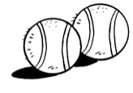 | B  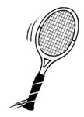 | C  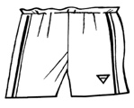

2 What did the hotel room not have?
A  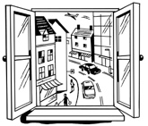 | B  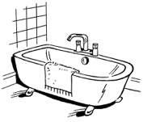 | C  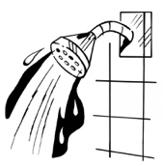

3 Which question was the easiest for the boy?

A  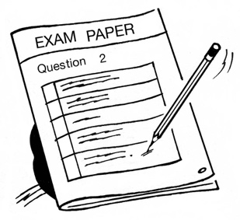 | B  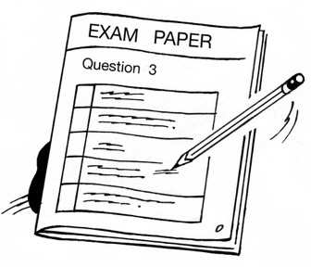 | C  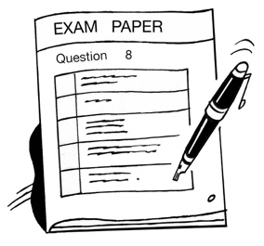

/ 3

14 Listen again and complete the sentences with two or three words in each gap.
1 The new sports shop was selling balls at ……………………… .
2 Flash Sports is less ……………………… the new sports shop.
3 Kerry’s mum booked ……………………… online.
4 The hotel was nearer ……………………… than the city centre.
5 Kerry and her family had to ……………………… because there were no buses.
6 Question 3 in the students’ exam paper asked about why Leonardo da Vinci ……………………… .
7 Ben could answer the question about Faraday because he did ……………………… about him.
/ 7

Total | / 10
Writing
15 Your teacher has asked you to write a story about a terrible journey. It can be a true story or one that
you invent.
Write 75–100 words.
………..……..………..……..………..……..………..……..………..……..………..……….…………..……..………..……..………..……..………..……..………..……..………..……….……
………..……..………..……..………..……..………..……..………..……..………..……….…………..……..………..……..………..……..………..……..………..……..………..……….……
………..……..………..……..………..……..………..……..………..……..………..……….…………..……..………..……..………..……..………..……..………..……..………..……….……
………..……..………..……..………..……..………..……..………..……..………..……….…………..……..………..……..………..……..………..……..………..……..………..……….……
………..……..………..……..………..……..………..……..………..……..………..……….…………..……..………..……..………..……..………..……..………..……..………..……….……
………..……..………..……..………..……..………..……..………..……..………..……….…………..……..………..……..………..……..………..……..………..……..………..……….……
………..……..………..……..………..……..………..……..………..……..………..……….…………..……..………..……..………..……..………..……..………..……..………..……….……
………..……..………..……..………..……..………..……..………..……..………..……….…………..……..………..……..………..……..………..……..………..……..………..……….……

/ 12
Speaking
16 It is the end of the school year and you want to organise a day trip to the country or the beach with your friend. Call your friend’s house and ask to speak to him/her. Discuss the details of your day trip.
/ 12

Total | / 110

