TOEFL PRIMARY

Part1
Exercise 1
Listen and choose the correct answer.
- Looking for a
- Film about pirates
- Program about pirates
- Video about pirates

- The actor in it is
- Tom Green
- Tom Red
- Tom Read

- It’s called
- Pleasure Word
- Measure World
- Treasure World

- It arrives on
- Wednesday Evening
- Wednesday Morning
- Wednesday Afternoon

- Would like a
- Video of the film
- Program of the film
- DVD of the film

- The name of the person is
- Tony
- John
- Alex

Exercise 2
Listen and choose the correct answer.
- Taking books out from the
- School
- Library
- Office

- Age
- 10
- 11
- 12

- In the family
- 2 grown-ups
- 3 grown-ups
- 5 grown-ups

- Person’s address
- 81 river street
- 82 arrival street
- 82 river street

- Name
- John
- Jack
- Vicky

- Needs computer on
- Sunday
- Saturday
- Monday

Exercise 3
Listen and choose the correct answer.
- Starting a new
- Job
- Sport
- Work

- Is good at
- Throwing and catching
- hitting and catching
- Throwing and hitting

- Would you like to try
- Football
- Basketball
- Volleyball

- Name
- Tom
- Fred
- Paul

- Days that are OK
- Thursday and Friday
- Tuesday and Wednesday
- Tuesday and Friday

- Needs
- Ball
- Jacket
- Shoes

Exercise 4
Listen and choose the correct answer.
- Going by … to visit Mary’s grandparents
- Bus
- Car
- Plane

- Can take
- Two bags
- Two big bags
- Two small bags

- In the small bag put
- A toothpaste
- A toothbrush
- A tooth-comb

- Choose … to read
- A comicage
- A book
- A journal

- Buy … for Mary’s grandparents
- Gift
- Card
- Present

- Leave home
- After breakfast
- After dinner
- After lunch

Exercise 5
Listen and choose the correct answer.
- Name
- Jack Sibly
- Jack Sibley
- Jack Sibliy

- He likes his … and all the children in his class
- Classroom
- Director
- Teachers

- Likes:
- Science and Math
- Math and Literature
- Geography and History

- Doesn’t like
- Geography
- Math
- English

Exercise 6
Listen and choose the correct answer.
- Name
- Bob Crawford
- Betty Crawfad
- Betty Crawford

- Birthday
- 20 June
- 20 July
- 12 July

- Address
- 14 Cornfield Street
- 40 Cornfield Street
- 14 Cornfilled Street

- Likes
- Volleyball and Basketball
- Football and Basketball
- Volleyball and Football

- Start
- 5th September
- 15th September
- 25th September

Exercise 7
Listen and choose the correct answer.
- Hotel
- Plaza
- Plizza
- Paza
- Time
- From 5 to 6
- From 5 to 7
- From 7 to 5
- Take photos of
- Trees, animals and people
- Woman and man
- Flowers, animals and people

Exercise 8
Listen and choose the correct answer.
- Restaurant:
- Neopolitana
- Nepolitata
- Neopolitaa
- Day and time: Wednesday at
- Half past 3
- Half past 4
- Half past 5
- Go by
- Bus
- Small bus
- Big bus
- Take:
- T-shirt, hat, towel
- Milk, water, flour
- Milk, T-shirt, towel

Part 1
Look at the picture. Read the words. Which word goes with the picture?
Fill in the correct circle on your answer sheet.
Let’s do two example questions.
1. 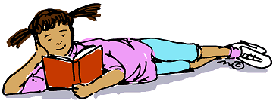
(A) Girl is reading
(B) Girl is talking
(C) Girl is doing homework

The answer is ‘A’. Fill in ‘A’ on your answer sheet.

2. 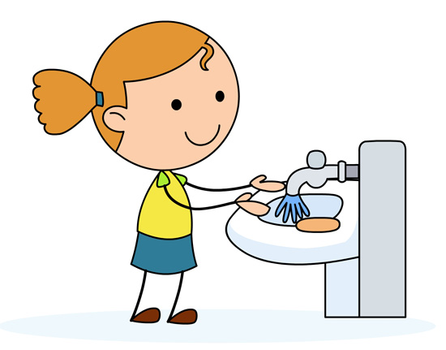
(A) Washes her body
(B) Washes her hands
(C) Washes her face

The answer is ‘B’. Fill in ‘B’ on your answer sheet.

3. 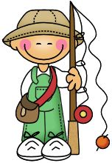
(A) Hiking
(B) Camping
(C) Fishing

4.
(A) Sales assistant
(B) Stewardess
(C) Actress

5. 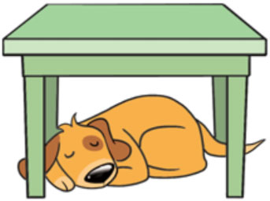
(A) The dog is between the tables
(B) The dog is under the table
(C) The dog is beside the table

6. 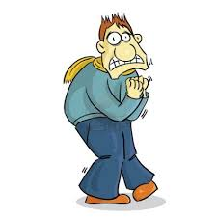
(A) Today it will be warm outside
(B) Today it will be storm outside
(C) Today it will be freeze outside

7.
(A) Shark
(B) Whale
(C) Coral
8. 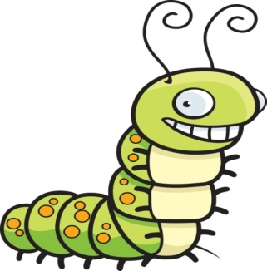
(A) Caterpillar
(B) Beetle
(C) Butterfly

9.
(A) Headphones
(B) Digital camera
(C) Computer

10. 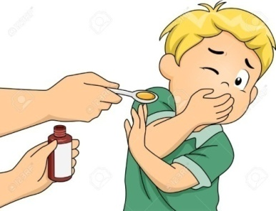
(A) Looks awful
(B) Smells unpleasant
(C) Smells comfortable

11.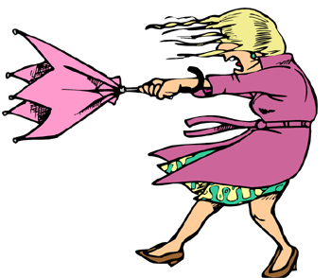
(A) Snowy weather
(B) Rainy weather
(C) Windy weather

12. 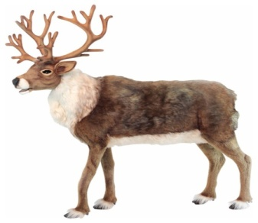
(A) Elk
(B) Crow
(C) Lizard
13. 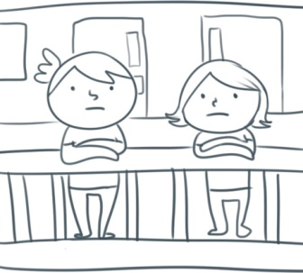
(A) Roof
(B) Balcony
(C) Wall
14. 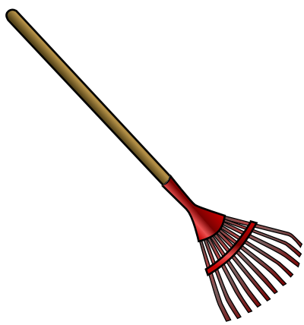
(A) Hoe
(B) Spade
(C) Rake

15.
(A) Palm
(B) Sand
(C) Umbrella

Part 2
Read and find the answer.
Fill in the correct circle on your answer sheet.
Let’s do an example.
16. It is a plant. It is eaten in salads. It is green.
(A) Lettuce
(B) Bread
(C) Carrot
The correct answer is Lettuce. Fill in ‘A’ on your answer sheet.

17. It means not civilized, primitive.
(A) Wild
(B) Wind
(C) Will
18. The quality or state of being physically strong.
(A) Weakness
(B) Strength
(C) Debility
19. It is used for painting by children. It has different colors.
(A) Pen
(B) Pencil
(C) Felt-tip pen

20. It is a large farm building. It is used for storing grain, hay, or straw or for housing livestock.
(A) Shanty
(B) Barn
(C) Shack

21. A large building. It was built typically of the medieval period. It has high walls.
(A) House
(B) Castle
(C) Skyscraper
22. A musical instrument. It has a bright tone. It is long. We blow into it to make the sound.
(A) Piano
(B) Guitar
(C) Trumpet
23. It is white. Used for writing or drawing on a blackboard.
(A) Crayon
(B) Chalk
(C) Pencil
24. A person, who walks rather than travels in a vehicle.
(A) Pedestrian
(B) Walker
(C) Passenger
25. There are colored lights, typically red, yellow and green, for controlling traffics.
(A) Traffic jam
(B) Traffic lights
(C) Traffic

Part 3
Fill in the correct circles on your answer sheet.
Read about the story. Answer questions 26 to 29.
Once upon a time, there lived two pigeons. They were husband and wife. They spend their day looking for food. In the evening they would come and rest on their favorite tree in the forest.
One evening, the wife returned home early. As usual she was waiting for her husband, when suddenly it started raining. She started to worry. “Where are you, my dear? You never get so late," she whispered to herself.
Just then she saw a bird-catcher coming towards her. In a cage he had a pigeon. It was her husband. “OH no, what shall I do now" I wish I can help my husband," she said. She desperately tried to distract the bird-catcher by flapping her wings, but all in vain.
Soon, it stopped raining. “Brrr!” It is so cold," said the bird-catcher. His clothes were wet. He decided to sit under the same tree where the two pigeons lived.
The poor wife sat by her husband’s cage. And she started to cry. The husband said. “Do not feel sad, dear. We now have a guest. This man is shivering and hungry. He needs your help." Hearing this, the wife flew around getting dry twigs. She made a fire for the bird-catcher. Then she looked at the bird-catcher and said, “You are our guest, since I have no food to offer, I will jump into this fire. In few minutes I will become an edible item for you. You can eat me."
By now, the bird-catcher was overwhelmed by the hospitality of the humble pigeon couple. He at once stopped the wife jumping into the fire.
He opened the cage and set the husband free. “I have been cruel and selfish. I will never trap any bird in my net again," said the bird-catcher and went away. The two pigeons were happy to be reunited.

26. Two pigeons were
(A) Couple
(B) Friends
(C) Neighbors
27. Husband
(A) Got into the trap
(B) Was lost
(C) Was hungry
28. What did bird-catcher do?
(A) Ate the pigeon
(B) Cut the tree
(C) Caught the bird
29. Bird-catcher was
(A) Angry
(B) Hungry
(C) Worry

Read about the story (Answer questions 30 to 32).
There was a grocery shop in a town. Plenty of mice lived in that grocery shop. Food was in plenty for them. They ate everything and spoiled all the bags. They also wasted the bread, biscuits and fruits of the shop.
The grocer got really worried. So, he thought "I should buy a cat and let it stay at the grocery. Only then I can save my things."
He bought a nice, big fat cat and let him stay there. The cat had a nice time hunting the mice and killing them. The mice could not move freely now. They were afraid that anytime the cat would eat them up.
The mice wanted to do something. They held a meeting and all of them tweeted "We must get rid of the cat. Can someone give a suggestion"?
All the mice sat and brooded. A smart looking mouse stood up and said, "The cat moves softly. That is the problem. If we can tie a bell around her neck, then things will be fine. We can know the movements of the cat".
“Yes, that is answer," stated all the mice. An old mouse slowly stood up and asked, "Who would tie the bell?" After some moments there was no one there to answer this question.

- What kind of shop was in the city?
- Pet shop
- Clothing shop
- Vegetable shop

- Grocer wanted to buy
- A cat
- A trap
- A cage

- What did the mice decide?
- To catch the cat
- To feed the cat by other delicious food
- To hang it the bell

Read about the story (Answer questions 33 to 35).
There was a little boy who just celebrated his birthday. His parents bought him a puppy as a birthday present. The puppy had very long ears.
One evening, he was playing with his puppy. The puppy was happily jumping about and wagging his tail. Then the little boy tried to tie the puppy’s ears into a knot. The puppy stopped wagging his tail.
The little boy then tried to tie the puppy’s ears into a bow. The boy chuckled but the puppy became quiet.
“Can you throw your ears over your shoulders like a regimental soldier?" asked the boy. The puppy put his head on the ground and whimpered. The little boy laughed and hugged the puppy. The puppy wagged his tail happily.

- The boy celebrated
- School graduation
- University graduation
- His birthday

- Puppy had
- A short tale
- Long shoulders
- Long ears

- What did the little boy try?
- To cut puppy’s ears
- To fold puppy’s ears
- To connect puppy’s ears to each other

Read about the story (Answer questions 36 to 39).
It was a hot summer day. A lion was feeling very hungry.
He came out of his den and searched here and there. He could find only a small hare. He caught the hare with some hesitation. "This hare cannot fill my tummy" thought the lion.
As the lion was about to kill the hare, a deer ran that way. The lion became greedy. He thought, "Instead of eating this small hare, let me eat the big deer". He let the hare go and went behind the deer. But the deer had vanished into the forest. The lion now felt sorry for letting the hare off.

- It was
- Cold weather
- Sunny weather
- Hot weather

- The main Character of the story is
- A deer
- A Hare
- A lion

- He found
- A deer
- A rabbit
- A bird

- What the word “den” means?
- Forest
- Cave
- Shelter

